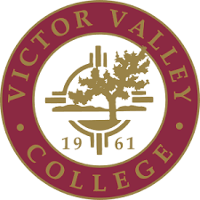

Instructional
Program Review Handbook
Victor Valley College

Table of Contents
Section | Content | Page
I. | Introduction | 3
 | The IPRC Mission | 3
 | Charge | 3
 | Current Membership | 4 - 5
 | Alignment with Campus Mission, Vision, District Goals and ILOs | 6 - 8
II. | Instructional Program Review Overview | 9
 | Purpose | 9
 | Objectives | 9
 | Format | 10
 | Program Review Timeline and Budget Allocation Process | 10 - 15
III. | Components of Instructional PRAISE Report | 16
 | Narrative | 16
 | Data Analysis | 16 - 17
 | Program Planning and Annual Augmentation | 17 - 18
 | Closing the Loop | 18
- IV. | Appendix | 19
 | List of Abbreviations | 19
 | Campus Links | 19
 | Definitions | 20
I. Introduction

Program Review (PR) at Victor Valley College is a self-assessment by its programs used to promote institutional effectiveness and provide the basis for budget and resource planning and allocation. It is a systematic process for the collection, analysis, and interpretation of student enrollment data and outcomes assessment data (SLO, PLO, and ILO) to produce the Program Review, Allocation, and Institutional Strategies for Excellence (PRAISE) report and update progress regularly. It is an instrument for identifying areas of change within its programs, and it is conducted to promote the effectiveness and relevance of instruction and the effective use of resources. These assessments are integral to the alignment of the programs’ goals with the mission of the college for college-wide planning. This Handbook describes the instructional program review process for Victor Valley College and outlines the process to be used for instructional programs.
Limitations of the program review process: Program Review is not a system of evaluating the performance of instructors. No part of the data collection process or analysis deals with instructional techniques or the quality of instruction in a particular class, nor may it be used as such. In addition, Program Review cannot be used in the Program Discontinuance process.

- The Instructional Program Review Committee (IPRC) Mission
The key responsibility of the Instructional Program Review Committee (IPRC) will be to provide orientation, training, guidance, and direction to the PRTs. The assigned Program Review Area Representative (PRAR) will assist the PRT throughout the program review process. The PRAR assignments will be related to areas of expertise. In addition, the Office of Institutional Research will assist the PRTs by preparing student enrollment data and other research as necessary.

- Committee Charge:

- Promote a sustainable practice of Program Review for ongoing improvement of Instructional programs in conjunction with the Non-Instructional Program Review Committee.
- Maintain the Victor Valley College Program Review Handbook and implement the processes outlined within.
- Provide support and promote integrity of the Program Review and PRAISE report process through an annual technical review.
- Evaluate and revise the process of Program Review based on inclusive feedback from Instructional programs in conjunction with the Non-Instructional Program Review Committee.

- Committee Membership:
As an Academic Senate committee, the IPRC will adhere to committee membership guidelines described in the By-Laws of the Academic Senate. The chairperson may recommend to the Academic Senate Executive Team (ASET) that additional committee members be added at any time.
The Committee will be responsible for
- providing documentation of the process.
- assisting PRTs in the completion of their PRAISE reports.
- receiving and reviewing draft proposal PRAISE reports for format and completeness.
- providing instructions for completing program review in TracDat/Improve.
- evaluation of process and making recommendations to the Academic Senate for revisions to the Program Review process and calendar.
- generating and submitting a Program Review Completion Report annually to the Academic Senate and to the Vice President of Instruction and Student Services.
- Designating which units/departments/programs must complete a program review. (The IPRC dictates which units/departments/programs must complete a program review, while administration selects individuals from units/departments/programs to lead the program review process in their respective areas. It is not the purview of the committee to mandate which individuals from mandated units/departments/programs completes a program review.)

CURRENT IPRC MEMBERSHIP &
PROGRAM REVIEW AREA REPRESENTATIVES

Program Review Area Representative | Guided Pathways Links
David Gibbs, Committee Chair  (David.Gibbs@vvc.edu) | Health Sciences Rampath &  Science, Technology, Engineering and Mathematics Rampath
Paul Tonning** (Paul.Tonning@vvc.edu) | Science, Technology, Engineering and Mathematics Rampath
Thomas Schellhous (Thomas.Shellhous@vvc.edu) | Science, Technology, Engineering and Mathematics Rampath
Peter Francev* (Peter.Francev@vvc.edu) | Arts, Humanities and Design Rampath
Henry Young* (Henry.Young@vvc.edu) | Business, Office Services and Law Rampath
Ed Heaberlin* (Wilbert.Heaberlin@vvc.edu) | Arts, Humanities and Design Rampath
Julia Wendt* (Julia.Wendt@vvc.edu) | Skilled Trades, Industry and Transportation Rampath & Personal and Career Exploration Rampath
Dave Oleson* (Dave.Oleson@vvc.edu) | Public Safety Rampath
April Garcia* (April.Garcia@vvc.edu) | Education, Society and Human Services Rampath
Joe Pendleton (Joe.Pendleton@vvc.edu) | Arts, Humanities and Design Rampath
- *Denotes they are currently serving as a Department Chair for their discipline.
- **Denotes they intermittently serve as Department Chair for their discipline.

Instructional Program Review Coordinator, 2021-2022
Regina Brown, Regina.Brown@vvc.edu

Classified Staff: Assessment & Accreditation Coordinator
Jan Espinoza, Jan.Espinoza@vvc.edu

- Alignment with Campus Mission, Vision, District Goals, and ILOs
Program Review reflects the mission, vision, values, district goals, and Institutional Learning Outcomes (ILOs) of Victor Valley College.

VVC’s Mission
Victor Valley College, in partnership with the community, is dedicated to providing opportunities for student learning and success through academic advancement, workforce development, and personal growth.

VVC’s Vision
Committed to equity and social justice, Victor Valley College will be the model of an innovative community college through exception student experiences that drive success, promote civic engagement, and meets community needs.

VVC’s Values
As a student-centered learning organization, VVC will uphold the following core values:
- Excellence – providing superior service and educational learning opportunities.
- Integrity – guiding the college’s actions with an internally consistent framework of principles.
- Accessibility – facilitating access to the college’s programs from other locations.
- Diversity – valuing inclusion and different points of view and contributions of all groups.
- Collaboration – encouraging recursive interaction of knowledge experience and mutual learning of people who are working together toward a common creative goal.
- Innovation – providing creative approaches to learning, problem solving, and growth.

VVC’s District Goals
Aligned with the 2020 Educational Master Plan, the District Goals of Victor Valley Community College are as follows:
- District Goal 1: Student Experience and Success
VVC will empower students and cultivate excellence in student learning and achievement, transfer-level course completion, engagement, retention, persistence, graduation, transfer, and job placement for its graduates. VVC will champion an equity-minded frame that fosters responsible attitudes toward cultural diversity, personal responsibility, community engagement, inclusivity, and cultural humility.
- District Goal 2: High Quality Practice/Excellence
VVC will continue to develop and implement high-impact, student-centered practices, showcasing VVC’s dynamic, diverse, and highly trained workforce, to promote equitable, innovative, and evidence-based best practices across all campus operations. VVC will continuously demonstrate the quality of its programs by conducting ongoing and systematic improvements using research, assessment, and the professional expertise of its workforce members.
- District Goal 3: Institutional Learning
VVC will transform its environment through its investments in a culture of inquiry that emphasizes engaged and collaborative learning through action research. Such powerful scholarship across campus will inspire meaningful contributions to the workforce and local community to create world class innovative teaching and student service practices. In turn, VVC will empower a new generation of lifelong learners with multi-cultural and global competencies.

VVC’s Institutional Learning Outcomes (ILOs)
The Institutional Learning Outcomes for Victor Valley College are as follows:
- Communication: Read and write analytically including evaluation, synthesis, and research; deliver focused and coherent presentations.

- Computation: Apply complex problem-solving skills using technology, computer proficiency, decision analysis (synthesis and evaluation), applications of mathematical concepts and reasoning, and the analysis and use of numerical data.

- Creative, Critical and Analytical Thinking: Apply procedures for sound reasoning in the exercise of judgment and decision-making; demonstrate intellectual curiosity and a respect for learning; solve problems through analysis, synthesis, evaluation and creativity; identify, evaluate and appropriate use of multiple sources of information.

- Social and Personal Responsibility: Evaluate the relationship between natural, social and economic systems and the significance of sustainability; demonstrate responsible attitudes toward cultural diversity, citizenship, personal contribution to local and international communities, and the effect of human actions on the environment.

- Information Competency: Students demonstrate information competency and critical thinking skills through their ability to effectively locate, retrieve, evaluate and utilize use library and information resources within the guidelines of academic standards to meet collegiate and personal information needs.

- Health and Human Flourishing: Synthesize educational aims into a holistic approach to the many facets of human flourishing; apply principles of physical, psychological and emotional health and fitness; demonstrate scholarly skills that support intellectual virtues for life-long learning; embrace concepts oof fiscal responsibility; and define goals that extend beyond oneself.

II. Instructional Program Review Overview

A. Purpose
The purpose of the Instructional Program Review process is to use measurable student enrollment data and outcomes assessment data, both quantitative and qualitative, to support the effectiveness of programs and improve the quality of education at Victor Valley College. Analysis of student enrollment and outcomes data allows for strategic planning and resource allocation with the goal of supporting student success. Program review also facilitates assessment of impact of resource and allocations disbursement by the district on instructional programs.

B. Objectives
The objectives of the Instructional Program Review at Victor Valley College are to:
- provide information concerning the alignment of a program’s mission and goals to the institutional mission.
- provide an analysis of student enrollment and outcomes assessment data to assess effectiveness, to identify strengths and weaknesses, and to provide direction for improvement.
- conduct and document dialogue within and across programs to promote the effectiveness and relevance of instruction and the effective use of resources.
- develop recommendations and evaluations for resource and budgetary allocation and implementation. Note: Current PRAISE reports, updates and related documents are live documents available for budget decisions at any time.
- provide an avenue to assess impact of resource and allocations disbursed by the district on instructional programs.
- comply with Federal and State law, including but not limited to California Education Code, Title 5, and Americans with Disabilities Act (ADA) as well as standards for Perkins, matriculation (including prerequisite and co-requisite standards), Accrediting Commission for Community and Junior Colleges (ACCJC), and other legal and certification requirements.
- Ensure that each program “closing the loop” for every program goal and approved budget augmentation.

C. Format
Instructional Program review will be completed in its totality in District-approved electronic software programs such as TracDat/Improve.

D. Program Review Timeline and Budget Allocation Process
i. Program Review Process within the Campus’ Strategic Plan
Program Review Process within the Campus’ Strategic Plan, Flow Chart
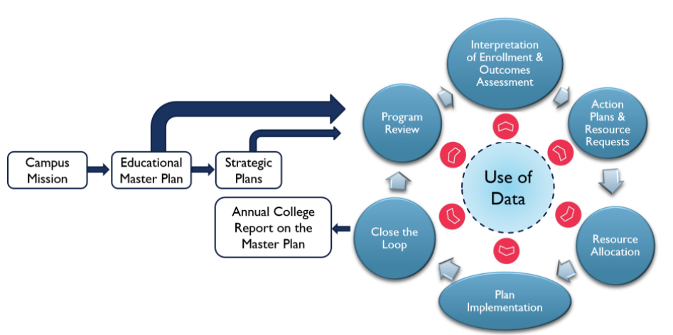

ii. Instructional Program Review, 4-year Cycle
Year 1: Comprehensive Program Review (CPR): Thorough analysis of the program, its student enrollment and outcomes assessment data, its climate/environment, and its new program plans, goals and resource needs based on the previous cycle of performance.
Years 2 and 3: Annual Program Update (APU): Provides any relevant updates on the program direction, program plans, enrollment and outcomes assessment data, and resource allocations and needs.
Year 4: Close the Loop Year (CTL): A self-study and update year where departments can follow-up and reflect on the program plans, resource requests, and strategies of the past cycle.
Instructional Program Review, 4-year Cycle Flow Chart

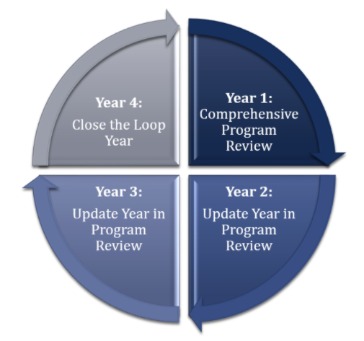

iii. Instructional Program Review and Budget Allocation
Per Administrative Procedure 6200 (AP6200): As described in Administrative Procedure 1202, Implementing Institutional Effectiveness, budget development is aligned with an annual program review and planning process that ensures campus-wide efforts in maintaining institutional effectiveness are adequately resourced. The timeline of budget planning activities is aligned with State mandates:

Mandates

1. The fiscal year of the District is July 1 through June 30.

2. The District’s chief financial officer, the Vice President of Administrative Services or designee, prepares a budget development calendar for the upcoming fiscal year’s planning and budgeting process.

3. The tentative budget is presented no later than July 1 per Title 5, §58305(a), and the adopted budget no later than September 15 per Title 5, §58305(c). according to Board Policy 6200, these budgets include a tentative list of revenue and expense expectations or budget assumptions developed by the Superintendent/President or his/her designee based on prevailing fiscal conditions and/or circumstances.

4. A public hearing on the budget shall be held on or before September 15 according to Title 5,
§58301.

5. On or before September 30, the District shall complete the preparation of its adopted annual financial and budget report.

6. On or before October 10, the District shall submit a copy of its adopted annual financial and budget report to the Chancellor’s Office pursuant to Title 5, §58305(d).

7. Quarterly financial reports (aka 311Qs) are presented to the Board of Trustees and the Chancellor’s Office.

8. Financial report CCFS 311 is presented to the Board of Trustees annually.

9. The College has customized processes for reviewing budget augmentation or resource requests from budgetary entities depending on the nature of the request. The Local and General Practice uses the process of program review to drive all budgetary decisions. This practice follows the general program review timelines where units request resources a year prior to the upcoming fiscal year. A second process is the Ad Hoc Practice process, enabling budgetary units to expedite resource requests relating to Legal Mandate(s), Health & Safety, Industry Standards factors & Accrediting Body Requirement(s). Both processes are outlined below. Budgetary entities requesting Staff or Faculty hires follow the Hiring Prioritization Committee and Rubric Process.

Following the completion of instructional program reviews, reports are submitted for consideration at higher campus levels, and follows the Budget Development administrative procedures delineated in AP6200.
Process Level | Description
Unit | Each Instructional Program reviews data, curriculum, etc., and completes comprehensive PRAISE, Goals and Resource Requests
Tier 1 | Division Dean reviews unit level reports, confers with program department chairs, and develops a priority recommendation for augmentation for the division
Tier 2 | The Vice-President of Instruction and Student Services reviews Tier 1 reports and develops a priority recommendation for all instructional programs to the FBPC
FBPC | FBPC reviews Tier 2 recommendations and applies the rubric outlined in the Board-approved AP 6200 document to develop a priority recommendation to the President/Superintendent for budget and augmentation
President/Superintendent | The President/Superintendent approves budget and augmentation requests and communicates the decision to the campus community

Sample Instructional Program Review and Budget Allocation, Flowchart
**The IPRC can amend deadlines based on extenuating circumstances so long as changes are provided and resources provided to assist units in completing their program reviews within the designated timelines.
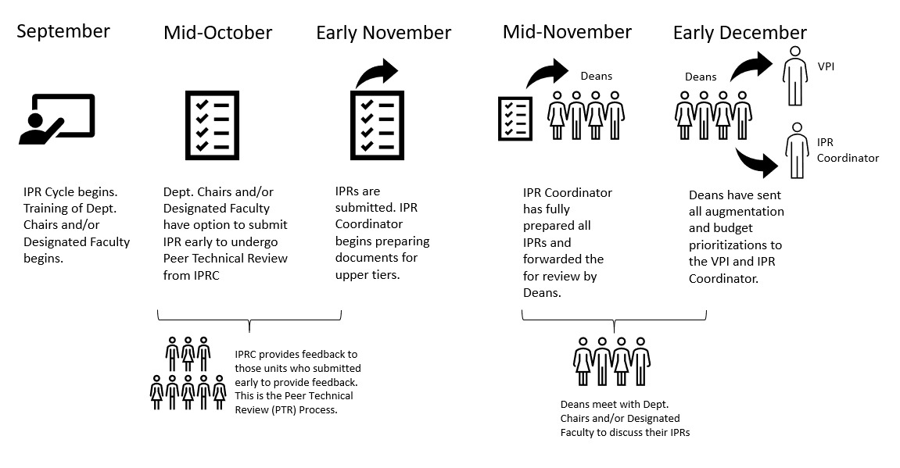

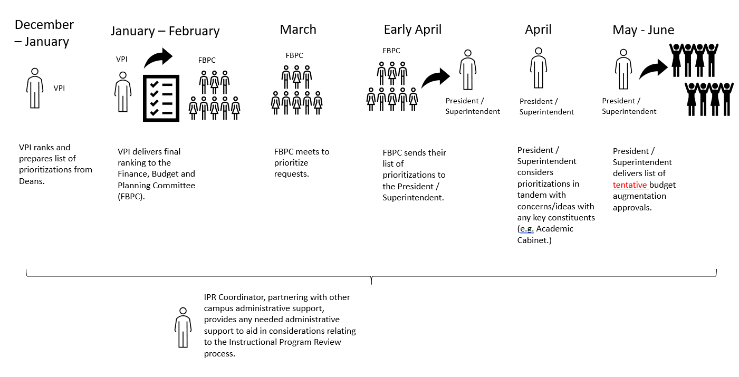

III. Components of Instructional PRAISE Reports

The instructional program review process will include the following components:
- Comprehensive PRAISE report (completed in TracDat/Improve)
- Data Analysis (Completed using Nuventive products)
- Goals and Resource Requests (completed in TracDat/Improve)

- The PRAISE Narrative
The Comprehensive PRAISE report should reflect the consensus of the members within the program. It is meant to provide a broad understanding of the program, current trends related to the program’s mission, and how the program serves to meet the overall mission and/or vision of Victor Valley College.
The Comprehensive PRAISE report addresses the following:
• alignment of both the program’s and college’s mission and goals (Board Policy 1200 PDF version Appendix B)
• program integration with the Educational Master Plan
• utilization of Program Learning Outcomes
• alignment of Program Learning Outcomes with Institutional Learning Outcomes
• historical background and unique characteristics of the program
• Strengths, challenges and trends of program curriculum
• Staffing structure
• Facility and technology needs
• Optional: service, community outreach, and economic development

- Data Analysis
Current student enrollment data include:
• Number of Courses Offered for Each Discipline
• Number of Sections Offered for Each Discipline
• Retention Rate by Discipline
• Success Rate (C or better) by Discipline
• Headcount (Unduplicated) by Discipline
• Enrollment (Duplicated) by Discipline
• FTES

o Demographic Information (duplicated headcount)
• Gender
• Age
• Ethnicity
Possible student enrollment data (available on request from the OIER):
• Concentrators by Discipline: e.g., Number of Students who have Successfully Completed 10 Units or More within the Discipline
• Number of Degrees/Certificates Awarded
• Grade Distribution by Course
• Summary of Retention and Success Rates for the Program
• Transfer rate by Program (if applicable)

- Program Planning and Annual Augmentation

Each instructional program will develop short-term and long-term program goals. Goals can be related to any aspect of the program. Example goal areas include, but are not limited to, the following:
• Staffing
• Curriculum
• Supplies
• Equipment
• Facilities
• Technology/technological infrastructure
• Community outreach/public relations
• Faculty professional development
• Tutoring services
• Student support services
• Etc.

Resource requests can be made for program goals identified and will enter the AP 6200 Budget Development process. Updates to progress of goals and obtainment of related resources are to be made annually. These updates are used to assess impact that resources and allocations disbursed by the district has on the program for institutional effectiveness.

- Closing the Loop

Each of the above cited areas require follow-up to determine program progress. Programs need to make updates on each program goal developed within the Goals and Resource Request section, and ensure that the data provided in the data component is being used to make data-driven and meaningful decisions to improve program progress and student success.

IV: Appendix
- List of Abbreviations
ASEB: Academic Senate Executive Board
CFIE: Center for Institutional Excellence
FBPC: Finance, Budget and Planning Committee
ILO: Institutional Learning Outcomes
IPRC: Instructional Program Review Committee
NIPRC: Non-Instructional Program Review Committee
OIER: Office of Institutional Effectiveness and Research
PRAISE: the Program Review, Allocation, and Institutional Strategies for Excellence (document)
PLO: Program Learning Outcomes
PR: Program Review (process)
PRAR: Program Review Area Representative
PRT: Program Review Team
SAO: Service Area Outcomes
SLO: Student Learning Outcomes
- Campus Links
Academic Senate Program Review Website
Center for Institutional Excellence (Program Review)
Institutional Research Office
Institutional Learning Outcomes
Board Policy 1200
Administrative Procedure 1201
Administrative Procedure 4000
Educational Master Plan

- List of Definitions
Definition of an Instructional Program for the Purpose of Program Review
For the purpose of Program Review, an “instructional program” is defined as an organizationally distinct planning and evaluation unit with formally recognized discipline leadership, which is specified in the Program List, and an identified function, mission, and/or purpose. A program may consist of a single discipline or a group of related disciplines which share joint leadership and academic purposes.
Definition of an Instructional Program for the Purpose of Program Learning Assessment
For the purpose of program learning assessment practice and reporting, an “instructional program” is a defined sequence or grouping of courses within a discipline required for the completion of a major, degree, or Chancellor-approved certificate at Victor Valley College.
Definition of “Closing the Loop” in Instructional Program Review
“Closing the Loop,” for the purposes of Instructional Program Review, is defined as ensuring that the results from the different components of the PRAISE reports (i.e. the narrative, the data and the budget augmentation) are annually followed up on and used for developing strategies to improve all aspects of each academic program or reporting unit. Programs must provide updates on each of their program goals, as well as provide information on the impact of budget augmentations. This is essential to effective planning and budgeting, as well as to the process of evaluating the effectiveness of the College’s programs.

D. The Legal and Professional Basis for Program Review

TITLE 5, Section 51022(a)
The governing board of each community college district shall, no later than July 1, 1984, develop, file with the Chancellor, and carry out its policies for the establishment, modification, or discontinuance of courses or programs. Such policies shall incorporate statutory responsibilities regarding vocational or occupational training program review as specified in section 78016 of the Education Code.

EDUCATION CODE, Section 78016
(a) Every vocational or occupational training program offered by a community college district shall be reviewed every two years by the governing board of the district to ensure that each program, as demonstrated by the California Occupational Information System, including the State-Local Cooperative Labor Market Information Program established in Section 10533 of the Unemployment Insurance code, or if this program is not available in the labor market area, other available sources of labor market information, does all of the following: (1) Meets a documented labor market demand. (2) Does not represent unnecessary duplication of other manpower training programs in the area. (3) Is of demonstrated effectiveness as measured by the employment and completion success of its students. (b) Any program that does not meet the requirements of subdivision (a) and the standards promulgated by the governing board shall be terminated within one year. (c) The review process required by this section shall include the review and comments by the local Private Industry Council established pursuant to Division 8 (commencing with Section 15000) of the Unemployment Insurance Code, which review and comments shall occur prior to any decision by the appropriate governing body.

ACCJC STANDARDS
Standard I.B. (in effect for Victor Valley College until June 2015)
Assuring Academic Quality and Institutional Effectiveness
Academic Quality
1. The institution demonstrates a sustained, substantive and collegial dialog about student outcomes, student equity, academic quality, institutional effectiveness, and continuous improvement of student learning and achievement.
2. The institution defines and assesses student learning outcomes for all instructional programs and student and learning support services. (ER 11)
3. The institution establishes institution-set standards for student achievement, appropriate to its mission, assesses how well it is achieving them in pursuit of continuous improvement, and publishes this information. (ER 11)
4. The institution uses assessment data and organizes its institutional processes to support student learning and student achievement.

Institutional Effectiveness
5. The institution assesses accomplishment of its mission through program review and evaluation of goals and objectives, student learning outcomes, and student achievement. Quantitative and qualitative data are disaggregated for analysis by program type and mode of delivery.
6. The institution disaggregates and analyzes learning outcomes and achievement for subpopulations of students. When the institution identifies performance gaps, it implements strategies, which may include allocation or reallocation of human, fiscal and other resources, to mitigate those gaps and evaluates the efficacy of those strategies.
7. The institution regularly evaluates its policies and practices across all areas of the institution, including instructional programs, student and learning support services, resource management, and governance processes to assure their effectiveness in supporting academic quality and accomplishment of mission.
8. The institution broadly communicates the results of all of its assessment and evaluation activities so that the institution has a shared understanding of its strengths and weaknesses and sets appropriate priorities.
9. The institution engages in continuous, broad based, systematic evaluation and planning. The institution integrates program review, planning, and resource allocation into a comprehensive process that leads to accomplishment of its mission and improvement of institutional effectiveness and academic quality. Institutional planning addresses short- and long-range needs for educational programs and services and for human, physical, technology, and financial resources. (ER 19)

